Problem 1: Induction Review (15)

Show $\sum_{i=1}^{n}{i}=\frac{n^{2}+n}{2}$

Base case $n=1$

$\sum_{i=1}^{1}{1}=\frac{1^{2}+1}{2}$ Substitution

$1=1$ Arithmetic

Induction Hypothesis: $\sum_{i=1}^{k}{i}=\frac{k^{2}+k}{2}$

Induction Step: $\sum_{i=1}^{k+1}{i}=\frac{{(k+1)}^{2}+(k+1)}{2}$

$\sum_{i=1}^{k+1}{i}=\frac{k^{2}+3k+2}{2}$ Arithmetic

$(\sum_{i=1}^{k}{i)+}(k+1)=\frac{k^{2}+3k+2}{2}$ Definition of Summation

$\frac{k^{2}+k}{2}+\left(k+1\right)=\frac{k^{2}+3k+2}{2}$ Induction Hypothesis

$\frac{k^{2}+3k+2}{2}=\frac{k^{2}+3k+2}{2}$ Arithmetic

∴ $\sum_{i=1}^{n}{i}=\frac{n^{2}+n}{2}$ Induction Principle

### Problem 2: False Proofs Review (10)

Falsify this fallacious proof.

Claim:    In a set of h horses, all horses are the same color.  
Proof:    Induction on h.  
Basis:     Let h = 1. With only one horse, all horses are the same color.

Induction:

For k ≥ 1, assume the claim is true for h = k and prove it is true for h = k + 1.  
Consider a set of horses H so that |H| = k + 1.  
Remove a horse x from the set to get set H’ with |H’| = k.  
Remove a different horse y from the set to get set H’’ with |H’’| = k.  
By the induction hypothesis, all the horses in H’ and H’’ are the same color.  
Therefore all the horses in H must be the same color.

The sets $H'$ could have one color of horse and $H''$ could have a different color horse. They are only guaranteed to have horses of the same color when there is only one horse, it doesn’t prove the set $\left|H\right|=k+1$ always has horses of the same color since you need to remove a different horse y and therefore doesn’t prove in a set of h horses all horses are the same color. All of set $H^{'}=\{x\}$ is equal to x and all of set $H^{''}=\{y\}$ is equal to y, however it doesn’t prove that $x=y$ in a set $\left|H\right|=\{x,y\}$

### Problem 3: Graph Thinking (25)

Show that every graph with two or more nodes and no self-loops contains two nodes that have equal degrees.

Since every time you add an edge the degrees of two nodes increase, there will always be at least two nodes with equal degrees. For example a graph with 3 nodes must have at least 2 edges, a graph with 5 nodes must have at least 4 edges. No matter where you place those edges the degree of two different nodes will increase together meaning that there will always be at least two nodes with equal degrees.

Problem 4: DFA Construction (25)

1. (10) Let ***D***be a language over { **a**, **b** } where ***D***= { *s* | *s* contains an even number of **a**'s and an odd number of **b**'s, and does not contain the substring **ab**}.  Give a DFA with five states that recognizes ***D***.

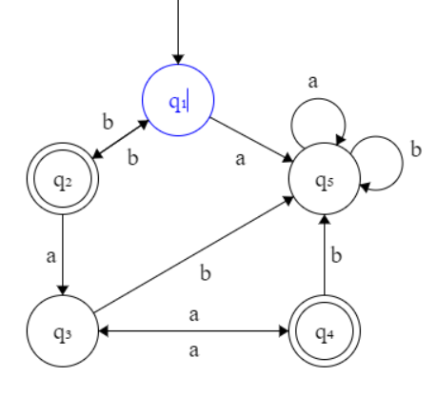

1. (15) In certain programming languages, comments appear between delimiters such as **/#** and **#/**.  Let ***C*** be the language of all valid delimited comment strings.  A member of ***C*** must begin with **/#** and end with **#/** but have no intervening **#/**.  For simplicity, assume that the alphabet for ***C*** is Σ = { **a**, **b**, **/**, **#**}.  Give a DFA that recognizes ***C***.

Problem 5: Regular Language Properties (25)

If ***M***is a DFA that recognizes language ***B***, you can manipulate the accept and non-accept states of ***M***to yield a new DFA, ***M'***, that recognizes the complement of ***B***.

1. (10) Determine the manipulation you need to obtain ***M'***.

If you make all accept states into non-accept states and all non-accept states into accept states you will obtain $M’$

1. (10) Show that ***M'*** recognizes the complement of ***B***.  You do not need an inductive or particularly formal proof, but you must convincingly argue it.
2. (5) Conclude, formally, that the class of regular languages is closed under complement.